Email Templates

- Day 1 Email:

Subject: [City or Region] can do better

Body:

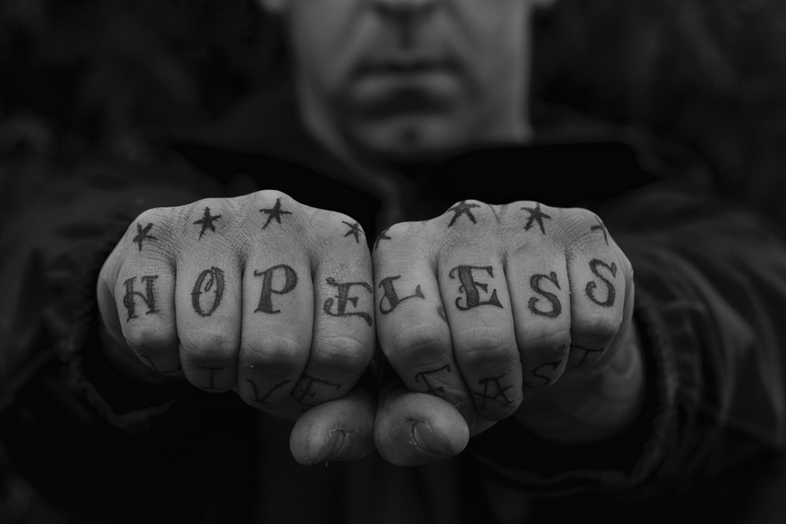

Every day, people in our community struggle to get by.

Many of our neighbors are barely making it day to day, just one car accident or emergency room visit away from financial crisis.

- Adults working two or three jobs to pay the bills experience more daily stress, have worse health, and spend less time with their kids
- Their kids are more likely to go to school hungry, not read at grade level and miss too many days of school, making it difficult to graduate from high school on time.

Thus, the cycle starts over again.

We can do better. [city or region] can do better.

United Way is the best way to make the biggest difference in city or region]. Please help us Fight for those families in our community who need a little support to get out of this cycle.
Learn More: [website link here]

